**NEPAL COLLEGE OF INFORMATION TECHNOLOGY**

**BALKUMARI LALITPUR**



**(Affiliated To Pokhara University)**

**SUBJECT : Database Management System**

**LAB REPORT # 4**

**TITLE :** Sub Queries & JOIN Queries

**Submitted By : Submitted To :**

**Name :** Pradip Dhungana **Name :** Amit K. Shrivastava

**Roll No :** 201751 **Department of Software**

**Semester :** 4th  **Date :** 2023/06/27

OBJECTIVE

To perform sub queries and join queries using DML.

LAB EXERCISE :

* Creating a Database named ‘lab4’.

= create database lab4;

= use lab4;

**OUTPUT :**

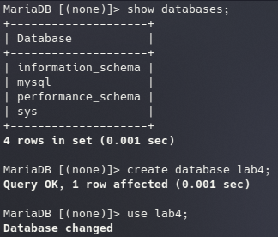

* Creating Tables and Inserting data.

**1) Customer Table :**

= CREATE TABLE customer ( cid INT, name VARCHAR(50), age INT, address VARCHAR(50), salary DECIMAL(10, 2) );

**2) Order Table :**

= CREATE TABLE `order` ( oid INT, order_date DATETIME, cid INT, amount DECIMAL(10, 2) );

**3) Employee Table :**

= CREATE TABLE employee ( eid INT, ename VARCHAR(50), job VARCHAR(50), did INT, salary DECIMAL(10, 2) );

**4) Department Table :**

=CREATE TABLE department ( did INT, dname VARCHAR(50), location VARCHAR(50) );

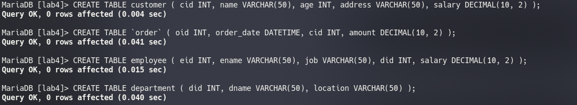 **OUTPUT :**

INSERTING DATA :   
**1) Customer Table :**

**=** INSERT INTO customer VALUES (1, 'ram', 32, 'kathmandu', 2000.00), (2, 'shyam', 25, 'patan', 1500.00), (3, 'hari', 23, 'dharan', 2000.00), (4, 'gopal', 25, 'pokhara', 6500.00), (5, 'sita', 27, 'bhaktapur', 8500.00), (6, 'gita', 22, 'illam', 4500.00), (7, 'rita', 24, 'banepa', 10000.00);

**2) Order Table :**

**=** INSERT INTO order VALUES (102, '2015-10-08 00:00:00', 3, 3000), (100, '2014-10-08 00:00:00', 3, 1500), (101, '2014-11-20 00:00:00', 2, 1560), (103, '2013-05-20 00:00:00', 4, 2060);

**3) Employee Table :**

**=** INSERT INTO employee VALUES (1, 'arjun', 'AP', 1, 10000.00), (2, 'rabi', 'JP', 2, 12000.00), (3, 'rohan', 'AP', 2, 15000.00), (4, 'krishna', 'AP', 1, 20000.00);

**4) Department Table :**

= INSERT INTO department VALUES (1, 'accounting', 'kathmandu'), (2, 'sales', 'patan'), (3, 'research', 'banepa'), (4, 'operations', 'bhaktapur');

**OUTPUT :**

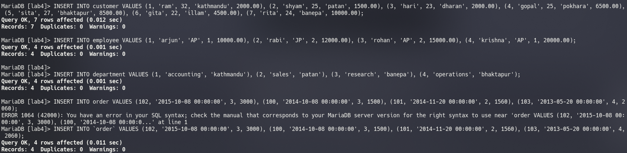

1) Display all employee names and salary whose salary is greater than minimum salary and job title starts with ‘J’.

= SELECT ename, salary FROM employee WHERE salary > (SELECT MIN(salary) FROM employee) AND job LIKE 'j%';

OUTPUT :

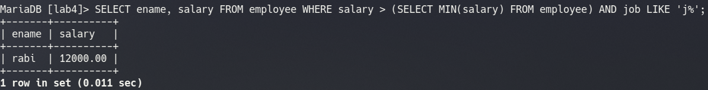2) Find all employees who work in the same job as ‘arjun’.

= SELECT * FROM employee WHERE job = (SELECT job FROM employee WHERE ename = 'arjun');

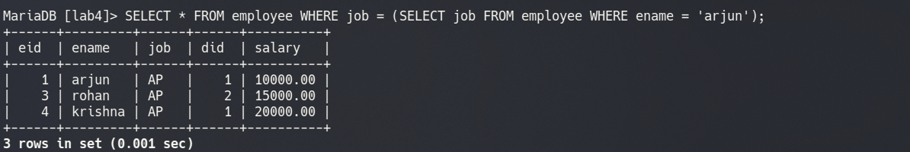OUTPUT :

3) Display information about employees who earn more than employee in

dept 1.

= SELECT * FROM employee WHERE salary > (SELECT MAX(salary) FROM employee WHERE did = 1);

OUTPUT :

4) Implement JOIN queries.

* **INNER JOIN :**

= SELECT customer.cid, customer.name FROM customer INNER JOIN `order` ON customer.cid = order.cid;

OUTPUT :

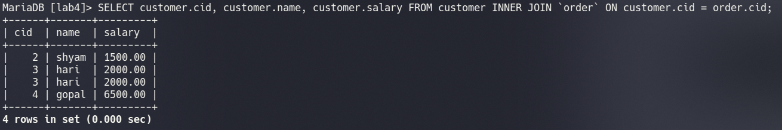

* **LEFT JOIN :**

= SELECT customer.cid, customer.name FROM customer LEFT JOIN `order` ON customer.cid = order.cid;

OUTPUT :

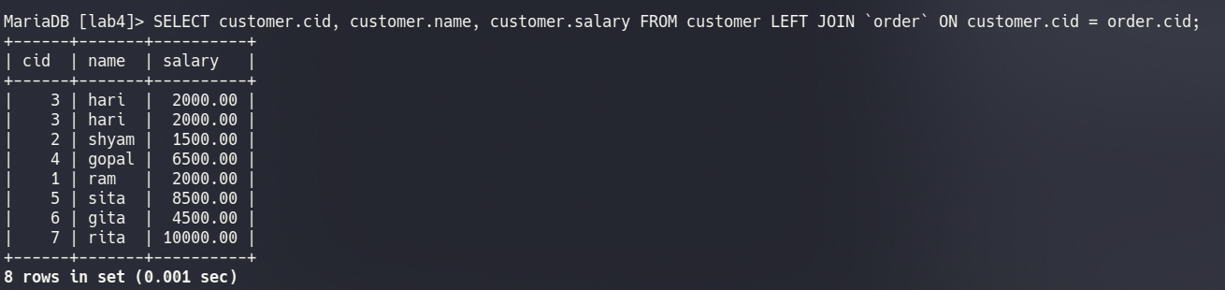

* **RIGHT JOIN :**

= SELECT customer.cid, customer.name FROM customer RIGHT JOIN `order` ON customer.cid = order.cid;

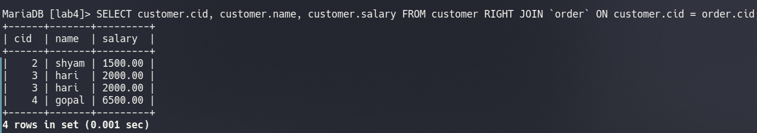OUTPUT :